Documentation on changes made to Hockshi by juniorhoza56@gmail.com

This document will try to outline all the changes made to the hockshi project .

Table of content
- FILE STRUCTURE CHANGES
- CHANGES MADE TO THE FUNCTIONS.JS FILE
- ENV CONFIGURATION
- HOW TO RUN THE APPLICATION

File Structure changes
in an attempt to follow the requirements stipulated in the SRS document which stipulated that the project should be built using an MVC architecture, i added a
- controllers directory
- models directory
- Migrations directory
- Seeders directory
- Containers directory
- Config directory
- Middleware directory

Controllers Directory
├── views │
├── adminController.js
├── BookController.js

This directory contains two main controllers which are the adminController.js and the BookController.js

adminController.js
The adminController.js file contains handler functions such as

-const login=(req,res):
The role of this function is to render admin_login page that contains a form for the admin to login
const login=(req,res,next)=>{
//the login function renders the login page that will request the email and password of the users who wishes to login
res.render("pages/admin_login",{
msg:false,
host:process.env.HOST
})
}

- Const formSubmit = async(req,res)
The form submit function is an asynchronous function that verifies the inputs entered by the user and if they are correct it redirect the user to the OTP page

const formSubmit= async(req,res,next)=>{
/*
the formsubmit funtion is an async function that is used to verify if the user who wants to login exists , the logic behind it's functioning is as follows
1. It extracts the email from the request body.
2. It then tries to find a user with the same email in the database.
3.If no user is found, it renders the "pages/admin_login" template with an error message.
4. If a user is found, it checks if the provided password matches the hashed password stored in the database.
5. If the password matches, it generates and sends an OTP (One-Time Password) for the user.
6. It then renders the "pages/otpVerification" template with the user's ID, email, and host.
7. If the password does not match, it renders the "pages/admin_login" template with an error message.
8.If an error occurs during the process, it logs the error to the console.
The function uses await to handle asynchronous operations and bcrypt.compare to compare the provided password with the hashed password. The powerUSer.findOne method is used to find a user in the database. The res.render method is used to render templates. The process.env.HOST variable is used to get the host of the application.

*/
const email=req.body.email
try {
const user = await powerUSer.findOne({
where: {
email: email,
}
});
if(!user){

res.render("pages/admin_login",{
csrfToken:req.csrfToken(),
msg:"please check your email and password again",
host:process.env.HOST
})
}
else{
if( await bcrypt.compare(req.body.password,user.password)){
user_email=email
userId=user.id
authUser=user.dataValues
generateAndSendOTP(user.id,user_email)
I res.render(`pages/otpVerification`,{
userId:userId,
email:user_email,
msg:false,
host:process.env.HOST
})
}
else{
res.render("pages/admin_login",{
csrfToken: req.csrfToken(),
msg:"please check your email and password again",
host:process.env.HOST
})
}
}
}
catch(e){
console.error('Error:', e);

}

}

- Const verifyOTP=(async(req,res))
As said earlier, when the user enters his correct login informations , an otp code will be generated and sent to his email. The verifyOTP function checks if the otp entered by the user in the otp form matches the otp generated and sent to his Emai

const verifyOTP=(async(req,res,next)=>{
/**
* The verifyOTP function is an asynchronous function that verifies a one-time password (OTP) sent by a user. It interacts with a database to check the OTP, handles validation errors, and manages user session data. If the OTP is valid and not expired, it sets up the user session and redirects to the dashboard.
*
*
*/

// Extract userId and OTP from the request body
const{userId,OTP}=req.body

// otpModel.findOne searches for an OTP record with the matching userId and OTP.
const otpRecord= await otpModel.findOne({
where:{
powerUserId:userId,
otp:OTP
}
})

/**
* validationResult(req) checks for any validation errors in the request.
If there are errors, render the otpVerification page with an error message.
*/
const errors=validationResult(req)
if(!errors.isEmpty()){
const {msg}=errors.array()[0]
res.render(`pages/otpVerification`,{
userId:userId,
email:user_email,
msg:msg,

})
return //stops futher execution if there is an error

}

/**
* If no OTP record is found, render the otpVerification page with an "invalid OTP record" message.
*/
if(!otpRecord){
authUser="";

res.render(`pages/otpVerification`,{
userId:userId,
email:user_email,
msg:"invalid OTP record",

})
}
/**
* If the OTP record is found but expired, render the otpVerification page with an "OTP expired" message.
*/
else if(otpRecord.expiration_time < new Date()){
authUser="";

res.render(`pages/otpVerification`,{
userId:userId,
email:user_email,

msg:"OTP expired",

})
}else{
/**
* If the OTP is valid and not expired:

Set up the user session with req.session.user.
Destroy the OTP record from the database to prevent reuse.
Redirect the user to the dashboard.
*/
req.session.user={
email:authUser.email,
role:authUser.role
}
await otpModel.destroy({
where:{
powerUserId:userId
}
})
res.redirect(`${process.env.HOST}/admin/dashboard`)
}
})
l

- Const dashboard=async(req,res)
This is the final step of the authentication flow, if the user entered the correct otp code , he will be redirected to his dashboard and it will be handled by this function , before rendering the page , it will fetch all the books present in our database

const dashboard=async(req,res)=>{
/*
Inside the dashboard handeler function, it first checks if a query parameter named msg exists in the request object. If it does, it assigns false to the msg variable; otherwise, it assigns the value of msg from the request query.

Then, it uses the await keyword to asynchronously fetch all books from the bookModel along with their associated genreModel and inventoryModel using the findAll method.

Finally, it renders a view template named "pages/dashboard" and passes the fetched books, msg, and the value of process.env.HOST as data to the template.
*/
const msg=req.query.msg?false:req.query.msg;

const books= await bookModel.findAll({
include:[
{model:genreModel},
{model:inventoryModel}

],

})
// res.send(user)
res.render("pages/dashboard",{
books:books,
msg:msg,
host:process.env.HOST

})
}

- Const logout =(req,res)
This route is used to logout the user , it first checks if the user is signed in by inspecting the req.session.user if the user is signed in , the program will delete the user attribute from the session object thus logging the user out after deleting this attribute, the user will be redirected to the login page

const logout=(req,res)=>{
/*
the logout function is used to logout signed in users.

It checks if the user is signed in by looking for the user property in the req.session object. If the user is not signed in, it responds with a status code of 404 and a message saying "user not signed in". If the user is signed in, it deletes the user property from the req.session object and redirects the user to the root URL of the admin section of the application (${process.env.HOST}/admin/).

*/
if(!req.session.user){
res.status(404).send("user not signed in")

}
else{
delete req.session.user
res.redirect(`${process.env.HOST}/admin/`)

}
}

BookController.js

The bookController.js contains mainly CRUD handler functions , the handle operation like create , read on the user table

- Const GetinsertBook= async (req,res)
The role of this function is to render the form that will permit the admin to add a book into the database , for the book to be created, all the values in the form should be filled

const GetinsertBook= async(req,res)=>{

/**
* The purpose of this function is to display a form for inserting a new book, pre-populated with a list of genres to choose from.

Here's what it does:

1. It asynchronously fetch all genres from the genreModel.
2. It then renders a view template named "pages/bookInsert" and passes the fetched genres, the host URL from 3. the environment variables, a msg variable set to false, and a formdata variable set to false.

*/
const genre= await genreModel.findAll()

res.render("pages/bookInsert",{
host:process.env.HOST,
genre:genre,
msg:false,
formdata:false

})
}

- Const CreateBook=async(req,res)

The create book is an asynchronous function which handles handles post requests for the creation of a new book, it checks if there are no errors with the data entered by the user , if there are errors the user will be redirected to the book insertion page with his errors

const CreateBook=async (req,res)=>{

/**
* The create book is an asynchrounous function which handles handles post requests for the creation of a new book
*/

//The function first checks for any validation errors using validationResult(req).

const errors=validationResult(req)

// If there are validation errors, it retrieves all genres from the database and adds an error message if no file (cover image) is uploaded.

if(!errors.isEmpty()){
const genre= await genreModel.findAll()

const error=errors.array()
if(!req.file){
error.push({

type: 'field',
value: '',
msg: 'Cover Image Is Required',
path: 'cover_image_url',
location: 'body'

})
}

res.render("pages/bookInsert",{
host:process.env.HOST,
genre:genre,
msg:error,
formdata:req.body
})

}else{
// If there are no validation errors, it creates a new book using the bookModel, and creates a new inventory using the inventoryModel.
let book= await bookModel.create({
title:req.body.title,
ISBN:req.body.ISBN,
genre:req.body.genre,
author:req.body.author,
description:req.body.description,
cover_image_url:req.file.path,
language:req.body.language,
price:req.body.price,
publication_date:req.body.date

})
inventoryModel.create({
book_id:book.book_id,
quantity_available:req.body.quantity,
location:req.body.location
})

return res.redirect(`${process.env.HOST}/admin/dashboard?msg=item+successfully+added`);
}
// File information is available in req.file
}

- Const updateBook=async (req,res)
Just as the GetinsertBook, this role of this function is to render the page containing the form that will enable the user to update a book

const updateBook=async (req,res)=>{
/**
* Inside the function, it uses the await keyword to asynchronously find a book by its primary key (req.params.id) from the bookModel and includes the associated genreModel and inventoryModel.

It then retrieves all genres from the genreModel using the findAll method.

Finally, it renders a view template named "pages/updateBook" and passes the fetched book, root path from the environment variable process.env.ROOT_PATH, the cover image URL from the book, and the fetched genres as data to the template.
*/
let book= await bookModel.findByPk(req.params.id, {include:[
{model:genreModel},
{model:inventoryModel}

]},)
const genre= await genreModel.findAll()

// res.send(book)
res.render("pages/updateBook",{
book:book,
root_path:process.env.ROOT_PATH,
image:book.cover_image_url,
genre:genre

})

}

- Const saveUpdate=async(req,res)
The saveUpdate function handles updating a book and its associated inventory record. It first retrieves the book and inventory records by the book ID, updates the fields with the new data, deletes the old cover image file if a new file is uploaded, and saves the changes to the database.

const saveUpdate=async(req,res)=>{
/**
* The saveUpdate function handles updating a book and its associated inventory record. It first retrieves the book and inventory records by the book ID, updates the fields with the new data, deletes the old cover image file if a new file is uploaded, and saves the changes to the database.
*/
try{
/**
* The function retrieves the book and inventory records from the database using the primary key (bookId). If the book or inventory records are not found, it returns a 404 error.
*/
const book= await bookModel.findByPk(req.body.bookId)
const inventory=await inventoryModel.findByPk(req.body.bookId)

if(!book || !inventory){
return res.status(404).send("record not found")
}
else{
//The function updates the fields of the book and inventory records with the data from the request body.

book.set({
title :req.body.title,
author : req.body.author,
ISBN :req.body.ISBN,
language : req.body.language,
price :req.body.price,
description :req.body.description,
publication_date:req.body.date,
genre:req.body.genre,
})

inventory.set({
quantity_available : req.body.quantity,
location:req.body.location,
})

if(req.file){
//If a new file is uploaded, the old cover image file is deleted from the file system, and the new file path is set.
const coverImagePath = path.join(process.env.ROOT_PATH, book.cover_image_url);
// Delete the cover image file
fs.unlink(coverImagePath, async (err) => {
if (err) {
return res.status(500).json({ error: 'Error deleting file' });
}
})

book.set({cover_image_url:req.file.path})

}
//The function saves the updated book and inventory records to the database.

await book.save()
await inventory.save()

//After successful update, the user is redirected to the dashboard with a success message.

res.redirect(`${process.env.HOST}/admin/dashboard?msg=item+successfully+updated`);

}

}

catch(e){
console.log("error",e)
res.status(500).send('Server error');

}

}

- Const deleteBook=async (req,res)
This functions is used to delete a book from the database and its cover image from the file system

const deleteBook=async (req,res)=>{

/**
* Deletes a book and its associated cover image from the server and database.
*
* This function performs the following steps:
* 1. Retrieves the book record from the database by its primary key (ID) provided in the request parameters.
* 2. Constructs the path to the cover image file associated with the book.
* 3. Attempts to delete the cover image file from the server's file system.
* 4. If the image deletion is successful, it deletes the book record from the database.
* 5. Redirects the user to the admin dashboard with a success message if the deletion is successful.
* 6. If an error occurs at any step, logs the error and redirects the user to the admin dashboard with an error message.
*
*/
let book= await bookModel.findByPk(req.params.id)
try{
const coverImagePath = path.join(process.env.ROOT_PATH, book.cover_image_url);
// Delete the cover image file
fs.unlink(coverImagePath, async (err) => {
if (err) {
return res.status(500).json({ error: 'Error deleting file' });
}
})

await book.destroy()
res.redirect(`${process.env.HOST}/admin/dashboard?msg=item+successfully+deleted`);

}
catch(e){
console.log(e)
res.redirect(`${process.env.HOST}/admin/dashboard?msg=error+when+deleting+record`);

}
}

Models Directory

├── models │
├── adminModel.js
├── BookModel.js
├── genreModel.js
├── index.js
├── inventory.js
├── OTPmodel.js

-adminModel.js

The adminModel.js file defines a Sequelize model for power users (administrators). This model is named powerUser and includes the following attributes:

- id: A unique identifier for each power user, which auto-increments.
- email: The email address of the power user, which is unique and required.
- password: The password of the power user, which is hashed before being stored.
- role: The role of the power user, which can be either "basic_admin" or "super_admin" with a default value of "basic_admin".
Hooks are equally included to perform some operation before the user is created

- BookModel.js
The bookModel.js file defines a Sequelize model for books. This model is named Books and includes the following attributes:

- book_id: A unique identifier for each book, stored as a string.
- title: The title of the book, which is a required string.
- author: The author of the book, which is a required string.
- ISBN: The ISBN number of the book, which is unique and required.
- description: A textual description of the book.
- price: The price of the book, stored as a decimal value.
- publication_date: The publication date of the book.
- language: The language in which the book is written.
- cover_image_url: A URL to the book's cover image.
- genre: A foreign key referencing the Genre model.
- Hooks are included to generate a book_id using an MD5 hash if it is not provided before creating or updating a book entry.

Associations are established between the Books and Genre models:

Each Book belongs to a genre (belongsTo association).
Each Genre can have multiple books (hasMany association).
This model helps in managing detailed information about books and categorising them by genre.

- genreModel.js
The genreModel.js file defines a Sequelize model for book genres. This model is named Genre and includes the following attributes:

- genre_id: A unique identifier for each genre, stored as a string.
- name: The name of the genre, which is a required string.
The model also includes hooks (callbacks) to generate a genre_id using an MD5 hash if it is not provided before creating or updating a genre entry.

This model helps in categorising books by genre and ensures that each genre has a unique identifier and a name.

- index.js
The index.js file is auto-generated by the Sequelize CLI and serves as the central point for initialising Sequelize and importing all models in the application. Key functionalities include:

- Reading database configuration from config.json.
- Initialising a Sequelize instance based on the environment configuration.
- Dynamically importing all model files in the current directory (excluding the file itself and test files).
- Setting up associations between models if they have an associate method defined.
This file ensures that all models are registered with Sequelize and that their associations are properly configured, making it easier to manage and query the database.

- Inventory.js
The inventory.js file defines a Sequelize model for managing the inventory of books. This model is named Inventory and includes the following attributes:

- book_id: A unique identifier for each book in the inventory, which is a foreign key referencing the Book model.
- quantity_available: An integer representing the number of copies available in the inventory.
- location: A string specifying the location of the book within the inventory.

Associations are established between the Inventory and Book models:
Relation (associations)

Each Book can have one inventory entry (hasOne association).

Each Inventory entry belongs to a single Book (belongsTo association).

This model helps in tracking the availability and location of books in the inventory, ensuring that each inventory record is linked to a specific book.

- OTPmodel.js
The otpModel.js file defines a Sequelize model for handling One-Time Passwords (OTPs) associated with admin users. This model is named otpTable and includes the following attributes:

- id: A unique identifier for each OTP entry, generated using UUID.
- otp: The actual OTP value stored as a string.
- expiration_time: A date-time value indicating when the OTP expires.
- powerUserId: A foreign key referencing the adminModel, indicating which power user the OTP is associated with.
The file also sets up associations between the otpTable and adminModel:

Relation (associations)
adminModel can have multiple OTP entries (hasMany association).

Each otpTable entry belongs to a single adminModel (belongsTo association).

This setup ensures that each OTP can be linked to a specific power user, and it enforces referential integrity between the OTPs and the users.

Migration directory

This folder/directory contains Sequelize migration files, which define the schema changes for various tables in the database. Each file corresponds to a specific table and includes commands to create and drop these tables.
To execute them , run npx sequelize-cli db:migrate –debug
To rollback the migrations , run : npx sequelize-cli db:migrate:undo:all, when this command is ran, it will execute all the async down() functions found in the migrations

- 20240528173709-create-OtpTable.js
This migration file creates the otpTable, which stores One-Time Passwords (OTPs) for power users. The table includes the following columns:

- id: A UUID that serves as the primary key, with a default value generated using UUIDv4.
- powerUserId: An integer that references the id column in the powerUser table, establishing a foreign key relationship.
- otp: A string to store the OTP value.
- expiration_time: A date-time value indicating when the OTP expires.

- 20240528173619-create-powerUsers.js
This migration file creates the powerUsers table, which stores information about power users (administrators). The table includes the following columns:

- id: An auto-incrementing integer that serves as the primary key.
- email: A string for the user's email, which is unique and cannot be null.
- password: A string for the user's hashed password, which cannot be null.
- role: An ENUM with values basic_admin and super_admin, defaulting to basic_admin and cannot be null.

- 20240528173326-create-inventory.js
This migration file creates the Inventory table, which manages the inventory of books. The table includes the following columns:

- book_id: A string that serves as the primary key and references the book_id column in the Books table. It cascades on delete and update.
- quantity_available: An integer specifying the number of copies available, which cannot be null.
- location: A string specifying the location of the book within the inventory, which cannot be null.

- 20240528145847-create-book.js
This migration file creates the Books table, which stores information about books. The table includes the following columns:

- book_id: A string that serves as the primary key.
- title: A string for the book title, which cannot be null.
- author: A string for the author's name, which cannot be null.
- ISBN: A string for the ISBN number, which must be unique and cannot be null.
- description: A text field for a detailed description of the book, which cannot be null.
- price: A decimal field for the book's price, which cannot be null and has a precision of 10 digits with 2 decimal places.
- publication_date: A date field for when the book was published.
- language: A string to specify the language of the book.
- cover_image_url: A string for the URL of the book's cover image.
- genre_id: A string that references the genre_id column in the Genres table. It establishes a foreign key relationship with cascading updates and deletions.
- 20240522172357-create-genres.js

This migration file creates the Genres table, which categorises books into different genres. The table includes the following columns:

- genre_id: A string that serves as the primary key.
- name: A string for the genre name, which cannot be null.

Seeders Directory
This directory contains seeders that will populate our database with initial values , these seeds should be used for testing

To run them use , execute , npx sequelize-cli db:seed:all --debug
To roll back the changes , execute ,npx sequelize-cli db:seed:undo:all --debug

- 20240527070940-seed-powerUsers.js
This seeder file populates the powerUsers table with initial data for administrator users. It uses bcrypt to hash passwords before inserting them.

Seeder Details:
- Dependencies: bcrypt for hashing passwords.
Data:
- email: The email of the power user.
- password: The hashed password.
- role: The role of the power user, either basic_admin or super_admin.
Example Data:

juniorhoza56@gmail.com with the role super_admin.
- 20240527070950-seed-genres.js
This seeder file populates the Genres table with initial genres.

Seeder Details:
Columns:
genre_id: The unique identifier for the genre.
name: The name of the genre.
Example Data:
Science
Fiction
Non-Fiction
- 20240527070951-seed-books.js
This seeder file populates the Books table with initial book data.

Seeder Details:
Columns:
- book_id: The unique identifier for the book.
- title: The book's title.
- author: The author's name.
- ISBN: The book's ISBN number.
- description: A description of the book.
- price: The price of the book.
- genre_id: The genre identifier, referencing the Genres table.
- publication_date: The publication date of the book.
- language: The language of the book.
- cover_image_url: The URL to the book's cover image.
- 20240527071020-seed-inventories.js
This seeder file populates the Inventory table with initial data regarding the quantity and location of books.

Seeder Details:
Columns:
- book_id: The unique identifier for the book, referencing the Books table.
- quantity_available: The number of copies available for the book.
- location: The location where the book is stored.

Containers Directory
This directory contains a docker-compose.yml file that contains the configuration used to create the mariadb image used for this project

version: '3.8'

services:
mariadb:
image: mariadb
restart: always
environment:
- MARIADB_ROOT_PASSWORD=password123!
- MYSQL_DATABASE=hockshi
volumes:
- ./data:/var/lib/mysql
ports:
- 3306:3306

#terminal cmd
#docker run -p 3306:3306 -d --name mariadb -e MYSQL_DATABASE=hockshi -e MARIADB_ROOT_PASSWORD=Password123! mariadb

It equally contains a command that can be executed in the terminal

Config Directory

This directory contains a config.json file that contains configuration to connect to databases , i has 3 main configuration , development , testing and production

{
"development": {
"username": "root",
"password": "Password123!",
"database": "hockshi",
"host": "172.17.0.2",
"dialect": "mariadb",
"port":"3306",
"logging": true
},
"test": {
"username": "root",
"password": null,
"database": "database_test",
"host": "mariadb",
"dialect": "mariadb"
},
"production": {
"username": "root",
"password": null,
"database": "database_production",
"host": "127.0.0.1",
"dialect": "mariadb"
}
}

By default, it will run the development configuration to switch it you can use the production or test configurations, you can do this by setting an environment variable

NODE_ENV = 'testing';

Middleware Directory

├── middleware │
├── verifyLogin.js
├── verifyBookForm.js
├── OTpmiddleware.js

This directory contains middleware

verifyLogin.js
This middleware checks if a user is logged in by verifying the presence of a user object in the session. If the user is not logged in, it renders a "not allowed" page. If the user is logged in, it allows the request to proceed to the next middleware or route handler.

Middleware Details:
Checks:
- Whether req.session.user is undefined.
Actions:
- If req.session.user is undefined, it renders the pages/notAllowedPage.
- Calls next() to proceed to the next middleware or route handler if the user is logged in.
/**
* Middleware to verify if a user is logged in.
*
* This middleware checks if the `user` object is present in the session. If the user is not logged in (i.e., `req.session.user` is `undefined`), it renders a "not allowed" page. If the user is logged in, it allows the request to proceed to the next middleware or route handler.
*

*/
const verifyLogin=(req,res,next)=>{
if (req.session.user==undefined){
res.render('pages/notAllowedPage')
}

next()
}

module.exports=verifyLogin

- verifyBookForm.js
This middleware array validates book form inputs to ensure they meet specified criteria. It uses an express-validator to perform the validations.

Middleware Details:
Fields Validated:
- title: Must be at least 1 character long.
- author: Must be at least 1 character long.
- ISBN: Must match a valid ISBN format.
- price: Must be a decimal number.
- quantity: Must be an integer.
- language: Must be at least 1 character long.
- genre: Must be an integer.
- date: Must be a valid date.
- description: (Optional) Must be no longer than 5000 characters.

/**
* Middleware array for validating book form inputs.
*
* This array of middleware functions performs various validations on the book form fields and handles validation errors.
*
*/

const { body, validationResult } = require('express-validator');

// Middleware to validate form inputs
const validateBookForm = [
// Title is required and should be at least 1 character long
body('title')
.trim()
.isLength({ min: 1 })
.withMessage('Title is required'),

// Author is required and should be at least 1 character long
body('author')
.trim()
.isLength({ min: 1 })
.withMessage('Author is required'),

// ISBN should be a valid string and required
body('ISBN')
.matches(/^(?=(?:\D*\d){10}(?:(?:\D*\d){3})?$)[\d-]+$/)
.withMessage('Invalid ISBN format'),

// Price should be a decimal number and required
body('price')
.isDecimal()
.withMessage('Price must be a decimal number'),

// Quantity should be an integer and required
body('quantity')
.isInt()
.withMessage('Quantity must be an integer'),

// Language should be at least 1 character long
body('language')
.trim()
.isLength({ min: 1 })
.withMessage('Language is required'),

body('genre')
.trim()
.isInt()
.withMessage('please select a genre'),

body('date')
.isDate()
.withMessage('select the release date'),

// Optional: Validate other fields like description, cover image URL, etc.
body('description')
.optional()
.trim()
.isLength({ max: 5000 })
.withMessage('Description is too long'),

// Middleware to check for validation errors
(req, res, next) => {

next();
},
];

module.exports = validateBookForm;

OTPmiddleware.js
This middleware array validates OTP (One-Time Password) inputs. It ensures that the userId is an integer and the OTP is exactly 6 digits long.

Middleware Details:
Fields Validated:
- userId: Must be an integer.
- OTP: Must be exactly 6 digits long.

/**
* Middleware array for validating OTP inputs.
*
* This array of middleware functions performs the following validations and operations:
* 1. Checks that the `userId` is an integer.
* 2. Ensures the `OTP` is exactly 6 digits long.
* 3. If there are validation errors, it stores them in the request object for later use.
*
* The middleware functions are executed in sequence.
*
*/

const { check,validationResult } = require('express-validator');

const validateOTP = [
// Check that 'userId' is an integer

check('userId').isInt().withMessage('User ID must be an integer'),
// Check that 'OTP' is exactly 6 digits long

check('OTP').isLength({ min: 6, max: 6 }).withMessage('OTP code must be 6 digits long'),
(req, res, next) => {

// Proceed to the next middleware or route handler

next();
},
];

module.exports=validateOTP

CHANGES MADE TO THE FUNCTIONS.JS FILE
The functions.js file is a js file that contains functions that will be used in the program, in this file i added 5 functions which are connect, generateAndSendOTP, Md5Rand, checkUploadDir,checkFileExtension

Const connect
This function establishes a connection with the database using Sequelize.

Function Details:
Purpose: To create and manage a connection to the database.
Returns: A Sequelize instance representing the database connection.
Logic:
- Close Existing Connection: If there's an existing connection (sequelize), close it.
- Create Sequelize Instance: Initialise a new Sequelize instance with database credentials from environment variables.
- Authenticate Connection: Attempt to authenticate the connection and log the result.
- Return Sequelize Instance: Return the newly created Sequelize instance.

let sequelize;
const connect = () => {
/**
* Function to establish a connection with the database using Sequelize.
* @returns {Sequelize} Returns the Sequelize instance representing the database connection.
*/
if (sequelize) {
// Close existing connection if it exists

sequelize.close().catch(err => console.error('Error closing old connection:', err));
}
// Create a new Sequelize instance

sequelize = new Sequelize(process.env.DB_NAME, process.env.DB_USER, process.env.DB_PSWD, {
host: process.env.DB_HOST,
dialect: 'mariadb',
logging: console.log,
});

// Authenticate the connection

sequelize.authenticate().then(() => {
console.log('Connection established successfully.');
}).catch(err => {
console.error('Unable to connect to the database:', err);
});
// Return the Sequelize instance
return sequelize;
};

Const generateAndSendOTP

This function generates an OTP (One-Time Password) and sends it to the specified email address.

Function Details:
Purpose: To generate a secure OTP and send it via email.
Parameters:
userId: The ID of the user associated with the OTP.
mail: The email address to which the OTP will be sent.
Returns: A Promise that resolves when the OTP is successfully sent.
Logic:
- Generate OTP: Create a random 6-digit OTP and set its expiration time to 15 minutes.
- Save OTP to Database: Connect to the database and save the OTP details.
- Configure Email Transporter: Set up a nodemailer transporter with Gmail credentials.
- Send Email: Send the OTP to the specified email address and log the result.

const generateAndSendOTP=async (userId,mail)=>{
/**
* Generates and sends an OTP (One-Time Password) to the specified email address.
* @param {string} userId - The ID of the user associated with the OTP.
* @param {string} mail - The email address to which the OTP will be sent.
* @returns {Promise<void>} A Promise that resolves when the OTP is successfully sent.
*/
const otpCode = crypto.randomInt(100000, 999999).toString();
const expiresAt = new Date(Date.now() + 15 * 60 * 1000); // OTP valid for 15 minutes
console.log(otpCode)
// Save OTP to the database
connect();
await otpModel.create({ powerUserId:userId, otp:otpCode, expiration_time:expiresAt });

const Transporter=nodemailer.createTransport({
service:'gmail',

auth:{
user:process.env.EMAIL_USER,
pass:process.env.EMAIL_PASS //google does not allow you to use your regular password for third party apps instead , you will generate an app pass , app passwords can only be generated for accounts with 2FA

}
});

const mailOptions = {
from: process.env.EMAIL,
to: mail,
subject: 'Your OTP Code',
text: `Your OTP code is ${otpCode}. It will expire in 15 minutes.`,
};
try{

await Transporter.sendMail(mailOptions,()=>{
console.log("Email sent successfully."); });
}
catch(e){
console.log("email error" , e)
}
}

Const Md5Rand
This function generates an MD5 hash of a random value.

Function Details:
Purpose: To create an MD5 hash from a random value.
Returns: The MD5 hash as a string.
Logic:
- Generate Random Value: Create a random value using Math.random().
- Generate MD5 Hash: Compute the MD5 hash of the random value.

const Md5Rand=()=>{
/**
* Generates an MD5 hash of a random value.
* @returns {string} The MD5 hash.
*/

// Generate a random value
const randomValue = Math.random().toString();

// Generate MD5 hash of the random value
return crypto.createHash('md5').update(randomValue).digest('hex');
}

Const checkUploadDir
This function checks if the upload directory exists(the uploads dir is directory where books cover images will be stored after upload), if i does not exists , it will create it

Function Details:
Purpose: To ensure that the uploads directory exists for storing uploaded files.

Logic:
- Construct Path: Builds the path to the uploads directory using the ROOT_PATH environment variable.
- Check Existence: Uses fs.existsSync to check if the uploads directory exists.
- Create Directory: If the directory does not exist, it uses fs.mkdirSync to create it.

const checkUploadDir=()=>{
/**
* this function Checks if the uploads directory exists and creates it if it doesn't.
*/

// Construct the path to the uploads directory

const uploadsDir = path.join(process.env.ROOT_PATH, 'views/uploads');
// Check if the uploads directory exists
if (!fs.existsSync(uploadsDir)) {
// Create the uploads directory if it doesn't exist

fs.mkdirSync(uploadsDir);
}
}

Const checkFileExtension
This function checks if the file extension is valid for image files (JPEG, JPG, PNG).

Function Details:
- Purpose: To validate the file extension and MIME type of uploaded images.
Parameters:
- file: The file object provided by multer.
- cb: The callback function to be called with the validation result.
- Returns: The callback function with the validation result.
Logic:
- Allowed Extensions: Defines a regular expression for allowed file extensions (jpeg, jpg, png).
- Check Extension: Tests the file's extension against the allowed extensions.
- Check MIME Type: Tests the file's MIME type against the allowed MIME types.
- invoke Callback: Calls the callback with null and true if both tests pass, otherwise calls the callback with an error message.

const checkFileExtension=(file, cb)=>{
/**
* Checks if the file extension is valid for image files (JPEG, JPG, PNG).
* @param {object} file - The file object provided by multer.
* @param {Function} cb - The callback function to be called with the validation result.
*/
// Allowed extensions
const filetypes = /jpeg|jpg|png/;
// Check extion
const extname = filetypes.test(path.extname(file.originalname).toLowerCase());
// Check mime
const mimetype = filetypes.test(file.mimetype);
// If both extension and MIME type are valid for images, return true

if(mimetype && extname){
console.log("file saved")
return cb(null, true);

} else {
// If either extension or MIME type is invalid, invoke the callback with an error

cb('Error: Images Only!');
}

}

3. ENV CONFIGURATION
In this chapter we will discuss about the changes made on the .env

ROOT_PATH=""
DB_PSWD="Password123!"
DB_USER="root"
DB_NAME="hockshi"
DB_HOST="ipaddress"
HOST="http://localhost:8000"

EMAIL_USER="juniorhoza56@gmail.com"
EMAIL_PASS="getYours at https://support.google.com/accounts/answer/185833?hl=en"

SESSION_MAXIMUM_TIME_IN_MILLI_SECONDS=259200000

- ROOT_PATH :
It contains the path to the root directory , initially it is set to an empty string and when the program will be executed
process.env.ROOT_PATH=path.join(__dirname, './');

This line of code will set the process.env.ROOT_PATH to whatever the root directory is
- DATABASE CONFIGURATIONS (DB_PSWD,DB_USER,DB_NAME_DB_HOST)
These environments variables stores the informations used by our program to connect to our database.
Note : DB_PSWD is the password used to login to our database
- EMAIL CONFIGURATIONS(EMAIL_USER,EMAIL_PASS)
These variables store information used by nodemailer (the js library used to send mails) to send mails. The EMAIL_PASS contains the app password that you will register at
https://support.google.com/accounts/answer/185833?hl=en

An app password is a 16-digit passcode that gives a less secure app or device permission to access your Google Account. App passwords can only be used with accounts that have 2-Step Verification turned on.
- SESSION_MAXIMUM_TIME_IN_MILLI_SECONDS
This variable contains the maximum lifespan of a cookie in milliseconds

4. HOW TO RUN THE APPLICATION
Step 1 : install dependencies
Execute : npm install

This command will install all the dependencies found in the package.json file
Step 2: download and run the mariadb image
If you are developing or using a linux machine, there are high chances you don't have docker desktop instep , to download and run the image you can use your terminal and run this command

Execute: docker run -p 3306:3306 -d --name mariadb -e MYSQL_DATABASE=hockshi -e MARIADB_ROOT_PASSWORD=Password123! mariadb

Step 3: connect to your database server and create sql commands

To connect to the mariadb server i used mysql workbench
3.1 connecting to mariadb server with mysql workbench

- Open mysql workbench
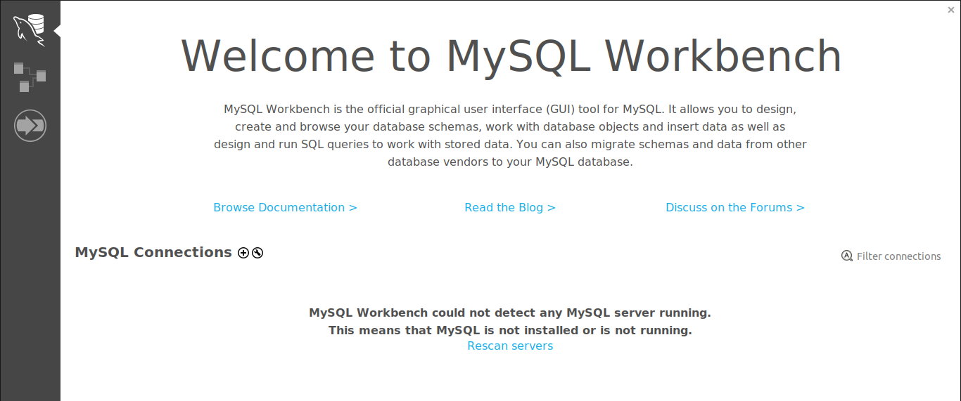

When you open mysql workbench , you will be greeted by this welcome window , to connect to database server , click on the + (plus sign ) next to MySQL connections

- Enter login credentials
Once you clicked on the add connection (+) a window will open where you will enter all your credentials necessary for you to connect to the server. It will look like this
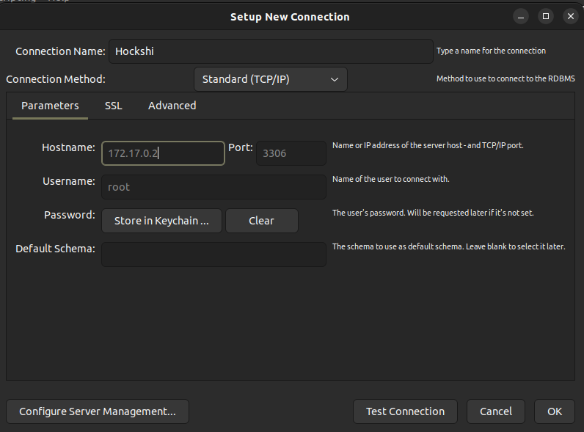

“If you do not know the ip address used by you mariadb server , execute docker inspect mariadb

And look for the IpAddress field (it is found close to the end of the result returned from the command)””

After filling in all the required information , you can click on Test connection that is found on the bottom of the window



Clicking on the Test Connection will open another window which will ask you to enter the servers password , (if you did not change the cmd found in the docker-compose.yml file the password is Password123!)
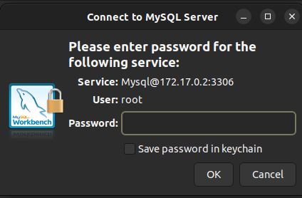

On this screen you will enter Password123! (but i highly recommend you to change this to something more secured), once this done , you can press ok and you will see the connection name on your welcome page

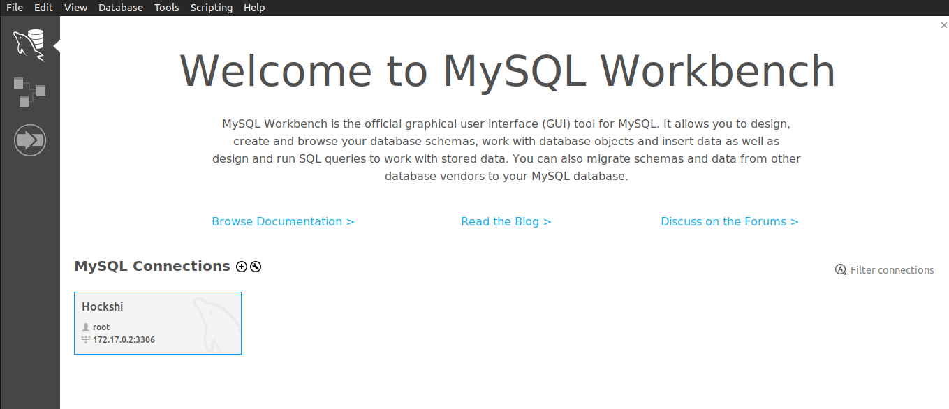

3.2 run sql commands

The next step we have to do is to populate our database with tables and data, this can be done in two different ways

1- running the commands found in database>hockshidb.sql
The hockshidb.sql file there are sql commands which you can use to create populate our database
Note: this file contains a command to create a default super_admin user

INSERT INTO powerUsers (id, email,password,role) VALUES (1, 'juniorhoza56@gmail.com','$2b$10$ksGTrtCJ4NCjqcYwar5vh.sW0lBLGlVY5TlJ8oVwVducQ13/YixcO',"super_admin");

--password = plaintextpassword

Change the email address to your email address , if this is not done , you will not be able to receive the otp code that will enable you to login

2- using sequelize-cli
In our project there are migrations which we can use to create tables in our database and we have seeders which we can use to insert data into our database

- To execute migrations, run npx sequelize-cli db:migrate –debug
- To execute seeders ,run npx sequelize-cli db:seed:all --debug

Step 4: run the application
After the pre configurations required to run our applications have been made , we can finally run our application

Execute : npm run dev

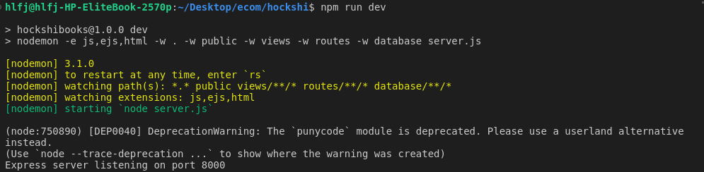

After executing the command , you should receive an output just like this

Step 5: access the application
To access the application you can enter this url in any browser of your choice
http://localhost:8000/admin/

Once you hit this endpoint , the server will respond with the login page

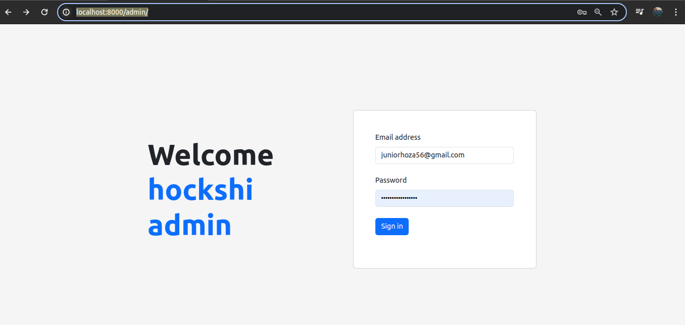

Verify that the information are correct and click on sign in,

If the informations are not correct you might receive and error just like this

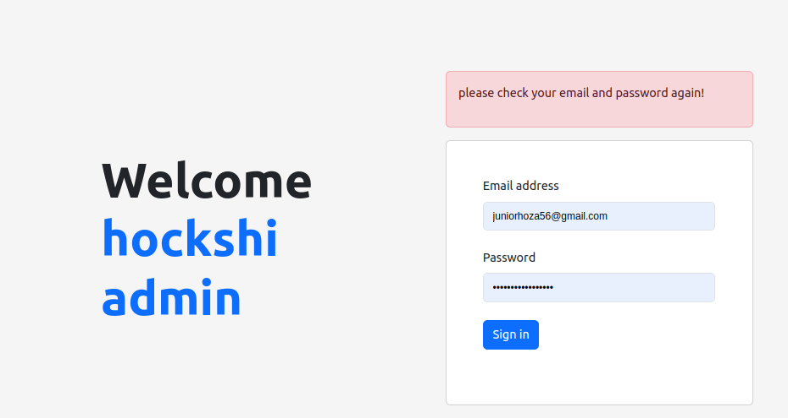

If every information is correct , you will be redirected to a second form that will ask you to enter the otp code sent to your email
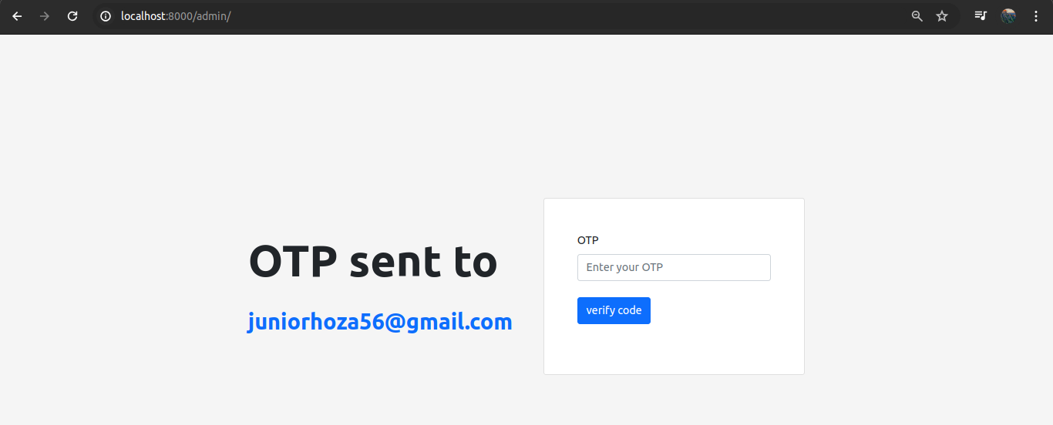

The email looks like this

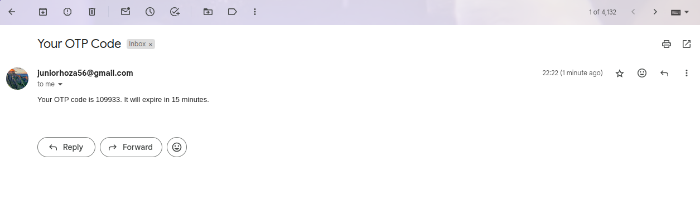
As stipulated on the email , every otp code have a life span of 15 minutes , after this time the otp code is not valid,

Copy the otp code and insert it in the verify OTP form, if the otp code is valid, you will be redirected to the dashboard

